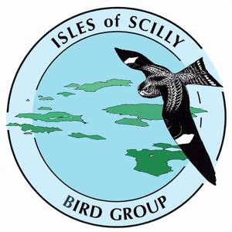 Isles of Scilly Bird Group

New Membership Application Form 2024-25

The Isles of Scilly Bird Group (ISBG) is pleased to offer membership arrangements for non-residents. Membership in the name of “Friends of the ISBG” is open to anyone, wherever they live, and is offered at an annual subscription of £20 in the UK and £20 plus postage for overseas. The purpose of this type of membership is to keep people in touch with the birding scene on Scilly and support the activities of the Group.

Our membership year runs from 1 August to 31 July of the following year and includes the Review for the preceding year e.g. membership for the period 1 August 2024 to 31 July 2025 will include the 2023 Review published in September 2023.

The ISBG was formed in 2000, initially to represent and encourage the wide range of interests of a growing number of resident birders. The ISBG also recognises an important role in supporting and informing non-resident birders whilst they are on or away from the islands. There are numerous ways in which the ISBG is able to provide support and information and our current plans are summarised below:

- Maintaining records on a daily basis
- Annual Isles of Scilly Bird and Natural History Review (free to Friends of the ISBG)
- Website with news, information and photographs
- Arrangements for each October’s birding season (trails, log call, etc)
- Projects in support of conservation and the environment

Completed membership application forms should be handed to any committee member or sent to:
Carole Cilia, Membership Secretary, Hivernia, Jackson’s Hill, St Mary’s, Isles of Scilly, TR21 0JZ
Email: membership@scilly-birding.co.uk

Name: ……………………………………………………………………………………………………

Address:
……………………………………………………………………………………………..

……………………………………………………………………………………………………………

………………………………………………….. Post Code: …………………………………….

Phone Number: ……………………………………...

E-Mail Address: …… ……………………………………………………………………………………

I wish to join ISBG for the period 1 August 2024 to 31 July 2025 at a subscription of £20.00 (£20.00 + postage overseas). Please tick here ______ if you pay tax and would like to receive a Gift Aid form. Thank you.

I wish to pay by cash / cheque / BACS (see below for account details). [Please delete as appropriate]

Please make cheques payable to “Isles of Scilly Bird Group” (not “ISBG”, as the bank will not accept this)

Signed……… …………………………………….. Date…………………………….

An additional form is available if, for next year’s membership (i.e. 2025/26), you would like to set up a standing order or you would like to pay by BACS transfer. Alternatively you can set up a Standing Order yourself using your name as the ‘Reference’, in favour of “Isles of Scilly Bird Group” Account No. 20133612. Sort Code: 20-67-19. Please tick this box to let us know if you intend to do this:

